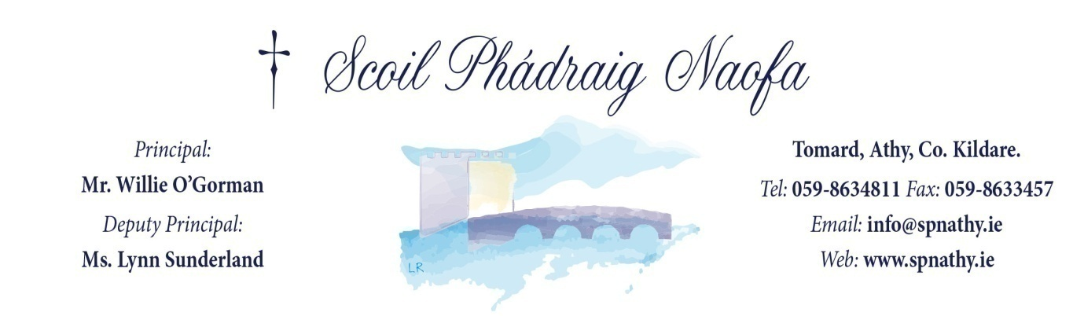
Scoil Phádraig Naofa Communion 2020

Do This in Memory of Me Masses will be held on the following dates in the Parish Church at 10.30am Mass

Sunday 13th October, 2019
Sunday 10th November, 2019
Sunday 8th December, 2019
Sunday 19th January, 2020
Sunday 23rd February, 2020
Sunday 8th March, 2020
Palm Sunday 5th April, 2020
Corpus Christi Sunday 14th June, 2020

First Penance
Wednesday 25th March, 2020 at 1.30pm in St Michael's Church

Communion Day
Sunday 10th May, 2020 at 12pm in St Michael's Church
