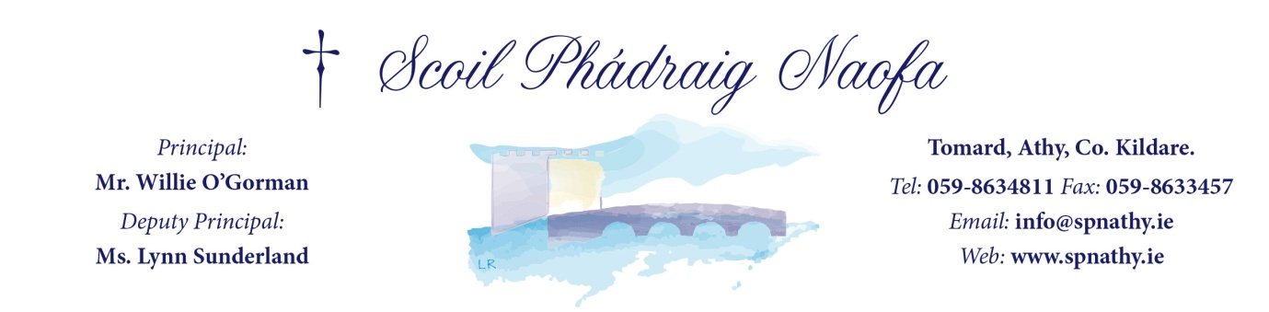
Scoil Phádraig Naofa – 16705E
ANNUAL ADMISSION NOTICE
in respect of admissions to the 2023/2024 school year

Admission Policy and Application Form
A copy of the school’s Admission Policy and the Application Form for Admission for the School Year 2023/2024 is available as follows: –
On request: By emailing info@spnathy.ie or writing to: Scoil Phádraig Naofa, Tomard, Athy, Co. Kildare.
Phone: Our school office on 0598634811

PART 1 - Admissions to the 2023/2024 school year

Application and Decision Dates for admission to Scoil Phádraig Naofa for the school year 2023/2024.
The following are the dates applicable for admission to Junior Infants

The school will commence accepting applications for admission on | Friday 13th January 2023
The school shall cease accepting applications for admission on | Friday 3rd February 2023
The date by which applicants will be notified of the decision on their application is | Friday 24th February 2023
The period within which applicants must confirm acceptance of an offer of admission is | 2 Weeks  Friday  March 10th 2023
*Failure to accept an offer within the prescribed period above may result in the offer being withdrawn

Note: the school will consider and issue decisions on late applications in accordance with the school’s admission policy

Special Class Application and Decision Dates for admission to Scoil Phádraig Naofa 2023/2024
The following are the dates applicable for admission to the school’s Special Class which caters for children with ASD - Autism Spectrum Disorder
The school will commence accepting applications for admission to the special class on | Friday 13th January 2023
The school shall cease accepting applications for admission to the special class on | Friday 3rd February 2023
The date by which applicants will be notified of the decision on their application for admission to the special class is | Friday 24th February 2023
The period within which applicants must confirm acceptance of an offer of admission is | 2 Weeks  Friday  March 10th 2023

*Failure to accept an offer within the prescribed period above may result in the offer being withdrawn

Number of places being made available in Scoil Phádraig Naofa 2023/2024

The number of places being made available in Junior Infants is | 75
The number of places being made available in the special class catering for children with ASD – (Autism Spectrum Disorder) Early Intervention is - | 4
The number of places being made available in the special class catering for children with ASD – (Autism Spectrum Disorder) Integrated Mainstream Classes is - | 0

PART 2 - Admissions to Scoil Phádraig Naofa 2022/2023

In respect of the school year 2022/2023
Information regarding the admission process for the Intake Group for Junior Infant Classes for the school year 2022/2023

In respect of 2022/2023 school year, the total number of applications for admission received by the school was 78.
Breakdown of places allocated for the 22/23 school year:
Number of places available: | 75
Number of applications received: | 78
Number of Offers made and accepted under each criteria: | Criterion 1:  77 Places Offered - 73 Place Accepted 4 Places Declined  Criterion 2:  1 Place Offered and 1 Place Accepted
Total number of offers made | 78
Number of names placed on waiting list for the school year concerned. | 0

PART 2 - Admissions to Scoil Phádraig Naofa 2022/2023

In respect of the school year 2022/2023
Information regarding the admission process for the Intake Group for Special Class ASD Integrated Mainstream Classes for the school year 2022/2023
In respect of 2022/2023 school year, the total number of applications for admission received by the school was 14
Breakdown of places allocated for the 22/23 school year:
Number of places available: | 4
Number of applications received: | 14
Number of Offers made and accepted under each criteria: | Criterion 1:  7 Places Offered and 3 Place Accepted  Criterion 3:  1 Places Offered and 1 Place Accepted
Total number of offers made | 8
Number of names placed on waiting list for the school year concerned. | 4

In respect of the school year 2022/2023
Information regarding the admission process for the Intake Group for Special Class ASD – Early Intervention Classes for the school year 2022/2023
In respect of 2022/2023 school year, the total number of applications for admission received by the school was 7.
Breakdown of places allocated for the 22/23 school year:
Number of places available: | 5
Number of applications received: | 7
Number of Offers made and accepted under each criteria: | Criterion 2:.  1 Place Offered and 1 Place Accepted  Criterion 3:  2 Places Offered and 2 Places Declined  Criterion 4:  Places Offered 4 and 4 Place Accepted
Total number of offers made | 7
Number of names placed on waiting list for the school year concerned. | 0

