Scoil Phádraig Naofa

Code of Behaviour and Discipline

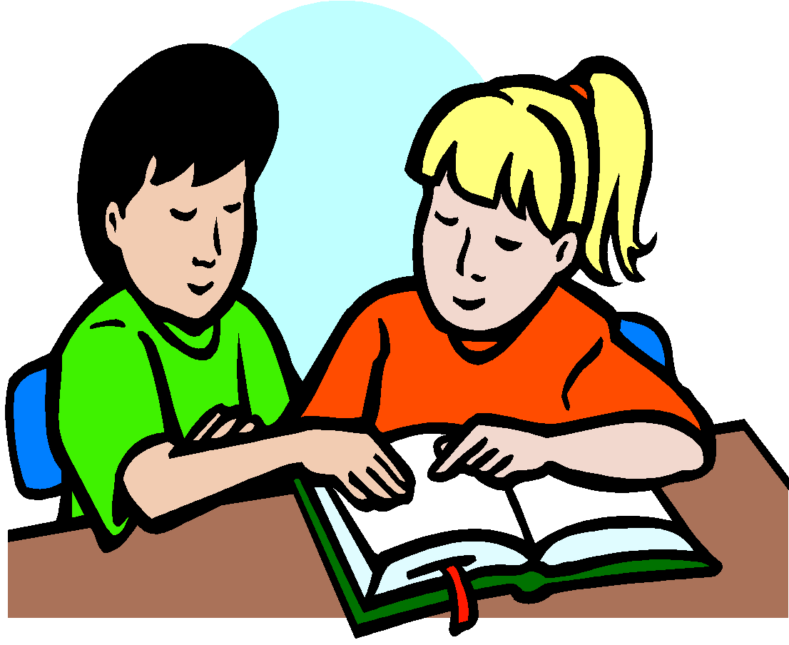

(Reviewed January 2024)

A Mission Statement of Scoil Phádraig Naofa

- The quality of the relationship between the teacher and the child is of paramount importance in the learning process in Scoil Phádraig Naofa. A relationship of trust, respect and empathy creates an environment in which the child is happier in school and more motivated to learn.
- The school strives to create and maintain a school environment, which is supportive of learning, by fostering a climate of welcome, discipline, care and learning. This learning environment is based on the principles of fairness and cooperation.

A Positive Approach

- Every effort is made by all members of staff of Scoil Phádraig Naofa to adopt a positive approach to behaviour and discipline within the school. Teachers use positive techniques of motivation and encouragement daily. These techniques are enforced within the various positive discipline strategies adopted by the school staff. See below.
- This school recognises the variety of differences that exist between children and takes this range of individual difference into account in the learning process when endeavouring to create an atmosphere of empathy throughout the school community.
- A high standard of behaviour is the result of a strong sense of community within the school, a high level of cooperation among the whole school community and a strong sense of compassion and empathy. (Pupils, Parents, Staff, Board of Management, Patrons)
- The rules of the school are kept to a minimum and are positively stated.
- All efforts are made to cater for differentiation, thus reducing the possibility of boredom or lack of learning opportunities.
- It is important that the rationale for the code is discussed with the pupils. It is vital that the rules are presented and taught to the pupils.
- In our Senior Classes teachers will promote, discuss and base much of their disciplinary discussions on the UN Convention of the Rights of the Child.

Responsibilities

- It is the responsibility of the teaching staff of Scoil Phádraig Naofa to ensure that the school’s Code of Behaviour is administered in a manner which is consistent and fair. The leadership of principal, deputy principal and other promoted teachers has a crucial bearing on the development of a collective responsibility among all the teaching staff and a sense of commitment to the school among parents and pupils.
- Each teacher has responsibility for the maintenance and communication of discipline within the classroom and for the discipline and safety of his/her pupils as they enter and leave class, as they walk along the corridor, and as they leave school.
- The role of Parents/Guardians is paramount. Their support is a crucial factor in enabling the staff of Scoil Phádraig Naofa to implement the Code of Discipline successfully.
- It is the joint responsibility of Parents/Guardians and Teachers to ensure that all relevant information regarding discipline issues is communicated in a fair, honest and swift manner.

Rights

- Teachers have a right to be allowed to teach, and to receive respect and good behaviour from their pupils.
- Pupils have the right to be actively involved in the learning process in an environment relatively free from disruption and distraction from their peers.
- Pupils have the right to be listened to at appropriate moments agreed by the teacher.
- Teachers, like all workers, have the right to expect to be treated with respect and dignity. They should be able to teach in a safe, well-maintained physical environment, relatively free from disruption. They have the right to the support and cooperation of Teaching Colleagues, Parents and Board of Management to achieve the school’s aims and objectives.
- All of these rights are underpinned by the UN Conventions on the Rights of the Child. https://www.oco.ie/app/uploads/2017/09/UNCRC_Poster_English.pdf

Strategies

It is important that good behaviour is not taken for granted. The following strategies are used in Scoil Phádraig Naofa to maintain a culture of good behaviour:

Classroom Strategies

Teachers and pupils collaborate to create a charter of rules and consequences for their classroom. Its aim is to encourage good behaviour and prevent poor behaviour. While pupils may contribute to the content of the charter, the Teacher takes responsibility for delivering the charter. The charter is classroom specific, but has commonality throughout the school. The rules are fair and acceptable. The rules apply to all pupils consistently, and respect the dignity of all. The charter needs to be supported by recognising ‘good’ behaviour when it occurs.

Creating a positive environment
- Praise: The good work and desirable behaviour is acknowledged by praise, helping build up the child’s self-esteem.
- Encouragement: Every pupil, working to the best of their ability, will receive encouragement and assistance.
- Work displayed in the classroom and around the school.
- Positive comments about a group’s desirable behaviour or the behaviour of the class to the principal when visiting the class.
- Being sent to the principal with a note about the child’s desirable behaviour.
- Being sent to a higher class to show off their work provided it does not cause embarrassment.
- Awards for Good Attendance.
- Poster promoting positive behaviour and the UN Convention of the Rights of the Child

Unacceptable or inappropriate behaviour has consequences and will be dealt with in accordance with the nature of such behaviour, using the following strategies:
- Reasoning with pupil;
- Highlighting the good behaviour of another pupil(s) while ignoring the behaviour of the offending pupil;
- Reprimand, including advice on how to improve;
- Temporary separation from peers, but never unsupervised;
- Loss of privileges;
- Prescribing additional work, while keeping to homework policy guidelines;
- Communication with parents;
- Referral to Principal Teacher for any serious breach of discipline, or for repeated incidents of minor misbehaviour;

These Strategies form the basis for sanctioning unacceptable behaviour in all classes and enable our Coloured Card System to operate. See Sanctions for Misbehaviour below.

Teachers will keep a record of all incidents of serious misbehaviour. See Record Keeping below.

Whole School Positive Discipline Strategies
The staff of Scoil Phádraig Naofa endeavours to promote good behaviour through the continued recognition of positive behaviour and effort. This process is supported by the following strategies -
School Reward System (Team Points)

The school reward system works on a four “Team” structure, with all the pupils and staff being a member of one of the following teams: Ulster, Munster, Leinster and Connacht. Each team constitutes an equal number of pupils and staff from each class grouping, which are listed and displayed in the school entrance hall.
The system operates by giving the pupils an opportunity to earn points for their team. All members of staff can award points once they observe appropriate behaviour. For example – observation of a pupil working to the best of their ability, being mannerly, supporting their peers, kindness and helpfulness, sportsmanship and completing assigned work to a very high standard, etc.

Totals are tallied each week when teachers upload weekly scores through our Google Drive Database to our co-ordinator . Weekly results are announced over the school intercom system or during the course of our whole school Google Meets.

At the end of each month the cumulative totals are calculated and the winning Team of the Month is announced. The system renews itself at the start of every month.

The victorious team is suitably rewarded with a Team Prize: for example, trips to a cinema, sports activities, local picnic, bus trip, Easter egg hunt, etc. This gives the whole team an opportunity to celebrate their success together.

Star Reward System

The Star Reward System is used to encourage and assist in the enforcement of certain school rules. Teachers will award stars to classes that are noticed adhering to specific rules. Once a class has accumulated a certain number of stars they are the beneficiaries of specific rewards.
At present the system is used to promote the following desired behaviour:
- Entering, exiting and lining up around the school and in the yard in an orderly civilised fashion.
- Wearing the appropriate school uniform.
- Tidy classroom
- During the course of the school years other whole school initiatives may be promoted through the use of our Star System.

Restorative Practice
The Staff of SPN trained in Restorative Practice in 2019. When investigating and dealing with difficult situations and serious disciplinary issues a Restorative Practice Approach will be used. The following Restorative questions will be used:
1. What happened?
2. What were you thinking at the time?
3. What have you thought about since?
4. Who has been affected by what you have done?
5. In what way have they been affected?
6. What do you think you need to do to make things right

Intervention
In the situation where a pattern of concerning or problematic behaviour emerges, Scoil Phádraig Naofa will always intervene early and take a proactive approach to resolving the challenges.

Intervention will involve selecting the most empathic and appropriate form of action at the time. The following are examples of some strategies -
- Discussion with relevant staff members.
- Conversations with parents and pupils.
- Meeting with Principal/Deputy Principal.
- Formal meetings with parents and pupils.
- HSCL Intervention
- Referral to Nurture Room.
- SEN Intervention.
- Drafting of School Support Plan
- Involvement of NEPS, NCSE, GP, CAHMS or other relevant outside organisations.

Sanctions For Misbehaviour

A. White/Yellow/Red/Blue Card System (All Classes)

Misbehaviour has to have consequences that are fair, consistent and transparent. The White/Yellow/ Red/Blue card system is designed to assist every teacher when enforcing school rules and recording pupil misbehaviour. The system works as follows:

White Card - Misbehaviour in Infant Classes

A White Card is used to record recurring incidences of misbehaviour or isolated incidents of gross misbehaviour in Infant Classes. White Cards may be used when a child is in breach of one of the following:

1. Disruptive behaviour in class or school environment.
2. Disrespectful language or behaviour used in School.
3. Damage to school property.
Once a pupil has accumulated 3 White Cards, his/her parents will be contacted by the class teacher to discuss their child’s behaviour.
Hereafter if a further 3 White Cards are recorded a meeting with parents, class teacher and principal will be organised.
A Reduced School Day may be implemented for any Infant who accumulates 9 White Cards. (See below)
In exceptional circumstances an Infant pupil may receive a Red Card which will automatically result in suspension. (See below).

Yellow Card – Serious Misbehaviour

A Yellow Card is given to a student once he/she is in breach of one of the following:

□ Use of offensive/disrespectful language.
□ Disruptive behaviour in school environment or while engaged in school activities.
□ Consistent lack of effort with school work.
□ Not complying with a teacher or a staff member’s request.
□ Running within the School Building.
□ Non Compliance with School Uniform Policy without Due Reason.

When a student has received 3 Yellow Cards he/she will receive a lunchtime detention.
Detention will involve the student remaining in for one lunch break to complete written exercises under adult supervision. A standard note will be sent home informing Parents/Guardians as to why their child is receiving detention. Parents/Guardians, Class teacher, Student and School Principal will sign this standard letter.
Blue Card / Detention Card

A Blue Detention card is given to a student once he/she is in breach of one of the following:
□ Serious Misbehaviour.
□ Act of Aggression.
□ Mobile Phone or Personal Digital Device switched on in School.
□ Repeated breach of a Yellow Card Offence.
□ Endangering the Health and of Safety Others.
□ Using racist or homophobic language in school.

A Detention Card is given by the Principal, Deputy Principal or Assistant Principal when a student’s behaviour is deemed to warrant an immediate once-off lunchtime detention.

3 Blue Cards over the course of a term or 5 Blue cards over the course of the year will result in suspension. For the purpose of integrating the Yellow and Blue Card system a Blue Card will be considered equivalent in value to 2 Yellows if determining whether or not a child has accumulated a total of 9 Yellows in term.

Red Card – Gross Misbehaviour

A Red Card is given to a student once he/she is in breach of one of the following:
A pupil will receive at least a one-day Suspension from school for a Red Card Offence. See Suspension below.
□ Cursing at a member of staff.
□ Serious Breach of our School’s Code of Discipline.
□ Repetitive use of offensive language.
□ Seriously endangering themselves or others.
□ Repeated breach of a Blue Card Offence
□ Using Mobile Phone or Personal Digital Device when in School or involved in a School Activity.
□ Accumulation of 9 Yellow Cards or 3 Blue Cards over the Course of a School Term.

B. Reduced School Day (All Classes)

If after communication with his/her parents/guardians, a pupil continues to disrupt the teaching and learning in the classroom, his/her parents/guardians will once again be contacted to inform them that their son/daughter is being put on reduced hours in school. The system works as follows:

The Parents/Guardians are required to co-operate with the procedure and sign an agreement outlining the following:
- The Reduced Day will be from 9.15am to 12.30pm (these times are subject to change depending on individual circumstances) during which time the core subjects of the curriculum will be covered.
- This will be for an initial period of two weeks, which will be reviewed every fortnight before the pupil returns to a full day.
- After two periods of reduced hours the pupil and his/her parents will meet with the principal and his class teacher to assess progress.

In keeping with the ethos of the school, Special Educational Needs Pupils will receive concessions (when deemed appropriate) from teachers when using the Card system. The behavioural difficulties of these pupils are sometimes directly related to their Special Educational Needs. Suspensions involving these pupils will only be used as a last resort when dealing with their challenging behaviour.

Suspension

Parents/ Guardians are contacted by the school Principal/Deputy Principal and informed of this sanction. Parents/ Guardians will also be required to arrange a meeting with the pupil’s Class Teacher, Principal and if necessary with the Chairperson of the Board of Management to discuss the matter. All suspensions will be submitted to the Education Welfare Board as is required by the school.

The sanction of Suspension will be used once a student has received a Red Card for an incident of Gross Misbehaviour (See above) or 9 Yellow Cards (See above).
In any case of gross misbehaviour the Board of Management authorises the Chairperson or the Principal to sanction an immediate suspension, pending a meeting between the school and parents. Pupils will be suspended for a temporary period in accordance with Rule 130(5) of the Rules for National Schools.

D. Expulsion

The Board of Management will only consider expulsion in extreme cases in accordance with Rule 130(6) of the Rules for National Schools

Special Educational Needs

In keeping with the ethos of the school, Special Educational Needs Pupils will receive concessions (when deemed appropriate) from teachers when using the Card system. The behavioural difficulties of these pupils are sometimes directly related to their Special Educational Needs. Suspensions involving these pupils will only be used as a last resort when dealing with their challenging behaviour.

Record Keeping

Teachers of Scoil Phádraig Naofa will keep a record of all instances of serious misbehaviour, as well as a record of improvement in the behaviour of pupils. Serious misdemeanours (bullying, aggressive behaviour, inappropriate language, and frequent breaches of our homework policy, vandalism etc.) will be recorded and dated, including a record of any action taken. A copy of such records may be sent to parents/guardians, or may form the basis for a meeting with parents/guardians of the offending pupil.

During the course of the school year all disciplinary records will be kept in the teachers file (Black Folder) and at the end of the school year relevant records will be transferred to the pupils file in the school office.

Samples of Record Keeping Forms:
- White Card (Infant Classes)
- Yellow Card
- Detention Letter
- Red Card
- Phone Call to Parent - Aladdin
- Meeting with Parent - Aladdin
- Incident Report Form - School Office
- Pupil Behaviour Log

Board of Management

The Board of Management has a role to play in the maintenance of desirable standards of behaviour in our school. It encourages parents/guardians in supporting its implementation, and the Board itself is supportive of the teachers in the application of this Code of Behaviour.

Reviewed January 2024

Appendix: 1

Scoil Phadraig Naofa - White Card

Name:______________________ Class:______________
Date:_____________
□ Disruptive behaviour in class or school environment.
□ Disrespectful language /behaviour towards fellow pupils or staff member.
□ Damage to school property.

Brief description of incident:
_________________________________________________________________________________________________________________________________________________________________________________________________________________________________________________________________________

Teacher’s Signature: _____________________________

Appendix: 2

Scoil Phádraig Naofa- Yellow Card
Name:_____________________ Class:__________
Date:______________
Reason for receiving a yellow card -
□ Use of offensive/disrespectful language.
□ Disruptive behaviour in school environment or while engaged in school activities.
□ Consistent lack of effort with school work.
□ Not complying with a teacher or a staff member’s request.
□ Running within the School Building.
□ Non Compliance with School Uniform Policy without Due Reason.
What Happened?
_________________________________________________________________________________________________________________________________________________________________________________________
What needs to be done to make things right?
_______________________________________________________________________________________________________________________________________________________________________________________________________________
Teachers Signature: ___________________
Child’s Signature: _____________________
Yellow Card No - _____

Appendix: 3

Scoil Phádraig Naofa- Blue Card
Name:_____________________ Class:_________
Date:____________
Reason for receiving a Blue Card -
□ Serious Misbehaviour.
□ Act of Aggression.
□ Mobile Phone or Personal Digital Device switched on in School.
□ Repeated breach of a Yellow Card Offence.
□ Endangering the Health and of Safety Others.
□ Using racist or homophobic language in school.
What Happened?
_________________________________________________________________________________________________________________________________________________________________________________________
What needs to be done to make things right?
_______________________________________________________________________________________________________________________________________________________________________________________________________________
Teachers Signature:___________________
Pupil’s Signature:_____________________
Parent’s Signature:____________________

Appendix: 4

Scoil Phádraig Naofa – Red Card
Name:________________________ Class _________
Date:_________
Reason for receiving a Red Card -
□ Cursing at a member of staff.
□ Serious Breach of our School’s Code of Discipline.
□ Repetitive use of offensive language.
□ Seriously endangering themselves or others.
□ Repeated breach of a Blue Card Offence
□ Using Mobile Phone or Personal Digital Device when in School or involved in a School Activity.
□ Accumulation of 9 Yellow Cards or 3 Blue Cards over the Course of a School Term.
What Happened?
_______________________________________________________________________________________________________________________________________________________________________________________________________________
What needs to be done to make things right?
_______________________________________________________________________________________________________________________________________________________________________________________________________________
Teachers Signature: ___________________
Child’s Signature: _____________________
Parent(s)/Guardian(s) Signature:___________________
School Principal: ________________________

